QuickSort Sorting Algorithm Tutorial and Detailed Walkthrough
Wed, 22 Apr 26
Quick Sort Algorithm Overview
- Sorting technique with different characteristics from other methods
- Uses divide and conquer approach
- Divides collection into subsets based on pivot element
- Recursively sorts subsets
Pivot Element Concept
- Element with specific properties that divides collection
- All elements to left are smaller than pivot
- All elements to right are larger than pivot
- Examples demonstrated:
  - Element 92: Cannot be pivot (63 on right is smaller)
  - Element 54: Valid pivot (meets both conditions)
  - Element 63: Invalid in first case (78 on left is larger)
- Pivot in sorted position when smallest/largest element is first/last
Partitioning Process
- Select pivot (first or last element of collection)
- Use two references: i (left to right) and j (right to left)
- Movement rules:
  - i moves right until finding element greater than pivot
  - j moves left until finding element smaller than pivot
  - Swap elements when both references stop
- Process complete when i crosses j
- Swap pivot with element at j position
Quick Sort Implementation Example
- Demonstrated with 9 barrels sorted by weight
- Initial pivot: 54kg barrel
- Partitioning steps:
  - i finds 78kg > 54kg, j finds 37kg < 54kg → swap
  - i finds 63kg > 54kg, j finds 28kg < 54kg → swap
  - i finds 92kg > 54kg, j finds 15kg < 54kg → swap
  - Continue until i crosses j
- Final swap: 45kg barrel with 54kg pivot
- 54kg now in sorted position
Recursive Application
- Left partition (elements < 54kg):
  - Pivot 45kg → partitioned with 15kg
  - Pivot 15kg → partitioned with 37kg and 28kg
  - Single elements automatically sorted
- Right partition (elements > 54kg):
  - Pivot 86kg → partitioned with 63kg and remaining elements
  - Continue recursively until all single elements
- Algorithm requires minimum 2 elements to operate
- Final result: all barrels sorted by weight
Quicksort algorithm complexity and implementation walkthrough
Wed, 22 Apr 26
Quicksort Algorithm Overview
- Divide and conquer recursive algorithm with 3 parameters:
  - Array to be sorted
  - Low index (leftmost position)
  - High index (rightmost position)
- Core process:
  - Check if low < high
  - Call partition algorithm to find pivot position
  - Recursively sort left partition (low to pivot-1)
  - Recursively sort right partition (pivot+1 to high)
Partition Algorithm Details
- Takes same 3 parameters as quicksort
- Pivot selection: first element (at low index)
- Two-pointer approach:
  - i starts at low index, moves right
  - j starts at high index, moves left
- Process within do-while loop:
  - Increment i while a[i] ≤ pivot
  - Decrement j while a[j] > pivot
  - Swap elements at i and j if i < j
  - Continue until i crosses j
- Final step: swap pivot with element at j position
- Returns j as partitioning element index
Best Case Time Complexity
- Optimal partitioning creates balanced divisions
- Number of partition levels: log₂(n)
- Comparisons per level: n elements
- Total complexity: O(n log n)
- Series representation: 2⁰ + 2¹ + 2² + 2³ + … = log n levels
Worst Case Time Complexity
- Occurs when array already sorted (ascending/descending)
- Pivot always becomes smallest/largest element
- Creates unbalanced partitions:
  - Left partition: empty
  - Right partition: n-1 elements
- Comparison series: n + (n-1) + (n-2) + … + 3 + 2 + 1
- Results in n recursive calls instead of log n
- Total complexity: O(n²) - quadratic time
Implementation Notes
- Worst case performance with pre-sorted data
- Algorithm effectiveness depends on pivot selection strategy
- Next video will cover practical implementation
Alright—this is the full Quick Sort (CSF style) using:
- quicksort() → recursion
- partition() → core logic
- swap() → utility
I’ll explain it exactly like previous ones:
- Concept + graphical steps
- Clean corrected code (merged from your images)
- Step-by-step explanation (all 3 methods)
- Time & Space complexity

🧠 Quick Sort — “Pick Pivot, Split, Repeat”
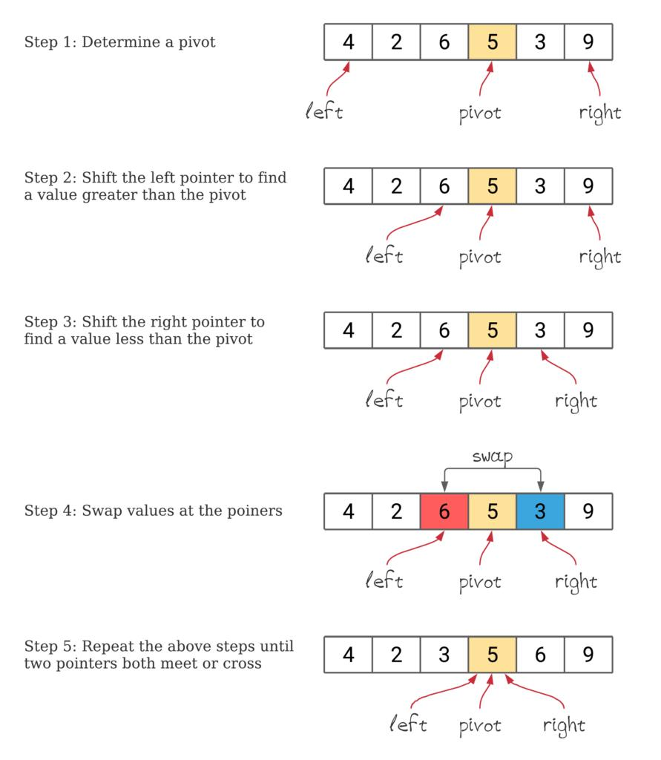
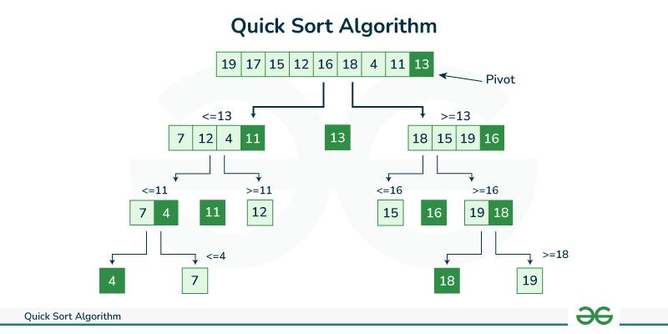
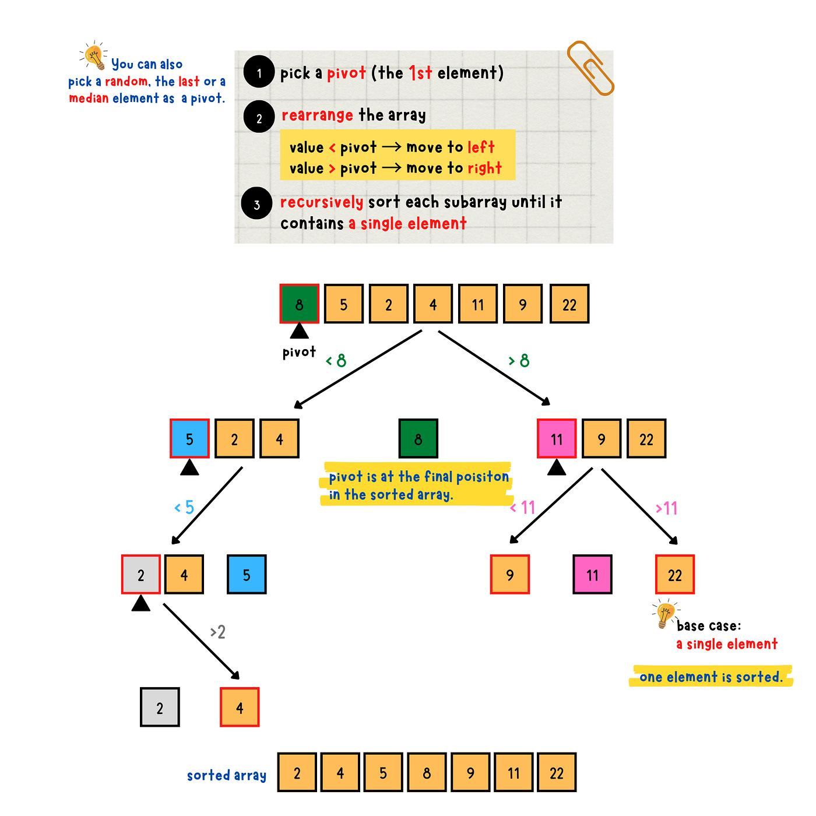
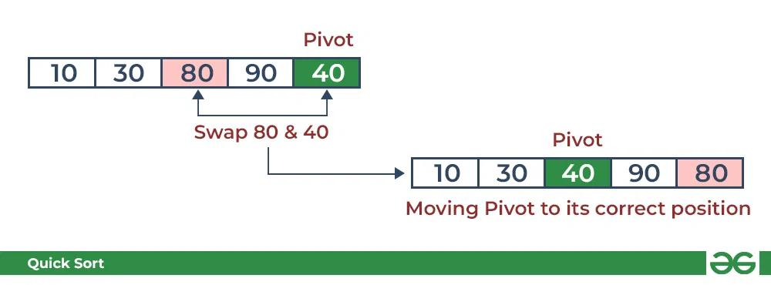
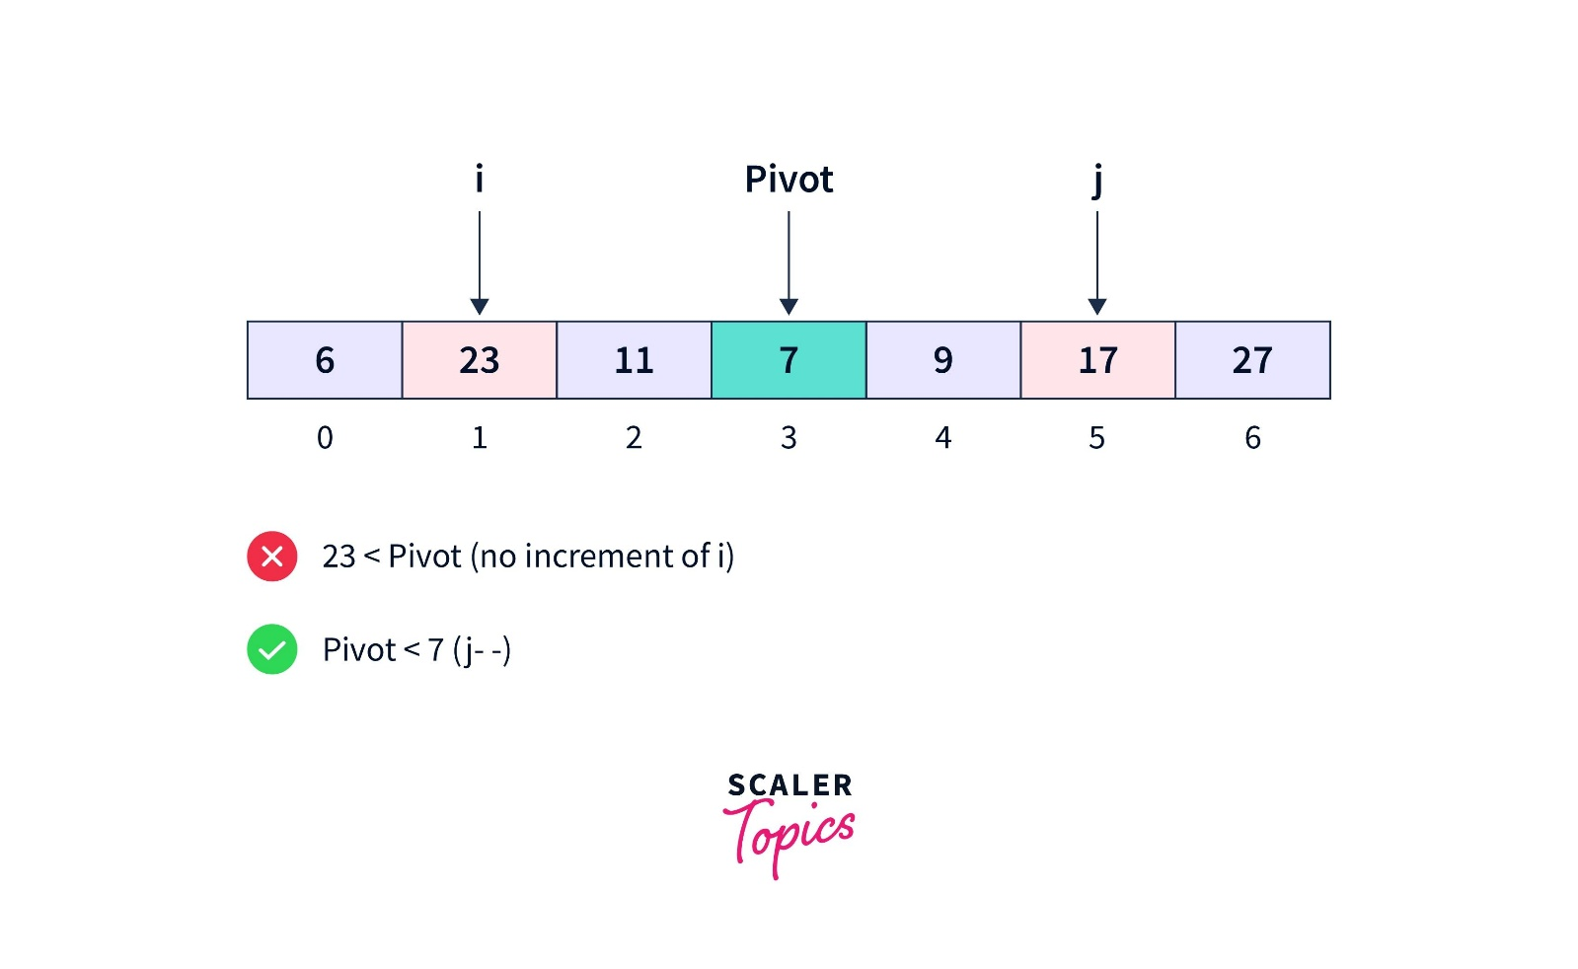
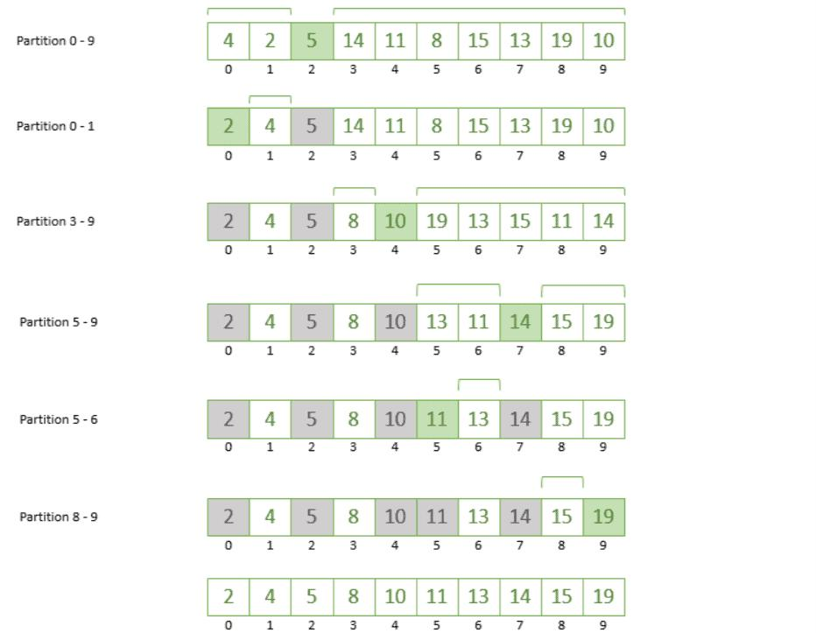
💡 Core Idea
- Pick a pivot
- Place it in correct position
- Left → smaller elements
- Right → larger elements
- Repeat recursively

🔄 PART 1: Step-by-Step Example
Take:
- [64, 25, 12, 22, 11]

🔹 Step 1: Choose Pivot
👉 Your code:
- pivot = A[low]
So:
- pivot = 64

🔹 Step 2: Two Pointers
- i → moves from left
- j → moves from right

🔹 Step 3: Move i and j
- Move i until element > pivot
- Move j until element ≤ pivot
👉 Swap when needed

Process:
- [64, 25, 12, 22, 11]
- p i j
- All elements < 64 → no swap needed
- Finally swap pivot with j
- [11, 25, 12, 22, 64]
✔ Pivot placed correctly

🔹 Step 4: Divide
- [11, 25, 12, 22] | 64

🔹 Step 5: Repeat Recursively
Next pivot = 11
- [11, 25, 12, 22]
→ already smallest → stays

Continue:
- [25, 12, 22]
- pivot = 25
→ becomes:
- [22, 12, 25]
→ then:
- [12, 22, 25]

✔ Final Sorted:
- [11, 12, 22, 25, 64]

🧾 PART 2: Clean Combined Code (Fixed from Images)
- public void quicksort(int[] A, int low, int high)
- {
- if (low < high)
- {
- int pi = partition(A, low, high);

- quicksort(A, low, pi - 1);
- quicksort(A, pi + 1, high);
- }
- }

- public int partition(int[] A, int low, int high)
- {
- int pivot = A[low];
- int i = low + 1;
- int j = high;

- do
- {
- while (i <= j && A[i] <= pivot)
- i++;

- while (i <= j && A[j] > pivot)
- j--;

- if (i <= j)
- swap(A, i, j);

- } while (i < j);

- swap(A, low, j);
- return j;
- }

- public void swap(int[] A, int i, int j)
- {
- int temp = A[i];
- A[i] = A[j];
- A[j] = temp;
- }

🔍 PART 3: Code Explanation

🔹 A. quicksort() (Driver Function)

1. Base Condition
- if (low < high)
👉 Stop when:
- One or zero elements

2. Partition Call
- int pi = partition(A, low, high);
👉 Finds:
- Correct position of pivot

3. Recursive Calls
- quicksort(A, low, pi - 1);
- quicksort(A, pi + 1, high);
👉 Sort left and right parts

🔹 B. partition() (Core Logic)

1. Choose Pivot
- int pivot = A[low];
👉 First element as pivot

2. Initialize Pointers
- int i = low + 1;
- int j = high;
Pointer | Role
i | find element > pivot
j | find element ≤ pivot

3. Move i Forward
- while (i <= j && A[i] <= pivot)
- i++;
👉 Skip smaller elements

4. Move j Backward
- while (i <= j && A[j] > pivot)
- j--;
👉 Skip larger elements

5. Swap Wrong Positions
- if (i <= j)
- swap(A, i, j);
👉 Fix misplaced elements

6. Loop Until Crossing
- } while (i < j);
👉 Stop when pointers cross

7. Place Pivot Correctly
- swap(A, low, j);
👉 Final pivot position

8. Return Pivot Index
- return j;

🔹 C. swap() Function
- int temp = A[i];
- A[i] = A[j];
- A[j] = temp;
👉 Simple value exchange

🧠 Mental Model
Step | Meaning
pivot | reference value
i | scan from left
j | scan from right
swap(i,j) | fix wrong positions
swap(low,j) | place pivot

📊 PART 4: Complexity Analysis

⏱ Time Complexity
Best Case
T(n)=O(n\log n)
👉 Balanced partition

Worst Case
T(n)=O(n^2)
👉 When pivot is smallest/largest

Average Case
- O(n log n)

💾 Space Complexity
- O(log n)
👉 Due to recursion stack

⚡ Key Insight
- Quick Sort is:
  - ✅ Very fast in practice
  - ✅ In-place (no extra array)
  - ❌ Worst case bad (if pivot poor)

🧩 Developer Insight
Your version uses:
- pivot = A[low]
👉 Not optimal for sorted arrays
Better options:
- Random pivot
- Median-of-three

🚀 Final Understanding
- Merge Sort → divide then merge
- Quick Sort → partition then divide
👉 That’s the key difference.

If you want next:
- I can compare Merge vs Quick visually (very important for interviews)
- Or show dry run table (i, j, pivot movement step-by-step)

